**GETECH CFX v1.5 Additions- DEPANELING EQUIPMENT**

**ToolParameters Class**

ToolParameters Class with the new parameters added based on our Depaneling Equipment under CFX.Production NameSpace

**Pull Request**

None

**Updates to the Standard**

**A.5 IPC-2591, Version 1.5 Changes**

|  |  |  |
| --- | --- | --- |
| **ToolParameter** | **Type** | **Description** |
| nodeTool Data Version | string | Value for the Tool Data Version |
| nodeTool Diameter | string | Value for the Tool Diameter |
| nodeFeed | string | Value for the Feed |
| nodeSpeed | string | Value for the Speed |
| nodeSlowSpeed | string | Value for the SlowSpeed |
| nodeSlewSpeed | string | Value for the SlewSpeed |
| nodeStartTime | string | Value for the StartTime |
| nodeNumberofboards | string | Value for the Numberofboards |
| nodeDistanceRouted | string | Value for the DistanceRouted |
| nodeDistanceAlarm | string | Value for the DistanceAlarm |
| nodeVacuumDistanceRouted | string | Value for the VacuumDistanceRouted |
| nodeVacuumFilterAlarm | string | Value for the VacuumFilterAlarm |
| nodeIncomingpressure | string | Value for the Incomingpressure |
| nodeSpindle | string | Value for the Spindle |
| nodeAxisspeedcceleration | string | Value for the Axisspeedcceleration |
| nodeActualpeakvelocity | string | Value for the Actualpeakvelocity |
| nodeActualpeakAcceleration | string | Value for the ActualpeakAcceleration |
| nodeAlarmtypeon | string | Value for the Alarmtypeon |
| nodeAlarmtypeoff | string | Value for the Alarmtypeoff |
| nodeVaccumlevel | string | Value for the Vaccumlevel |
| nodeMachinepower | string | Value for the Machinepower |
| nodeGripperforcelocation | string | Value for the Gripperforcelocation |
| nodeGripperforceplacement | string | Value for the Gripperforceplacement |

**Messages: CFX.Production.ToolParameters**

**CFXMessageFormat:**

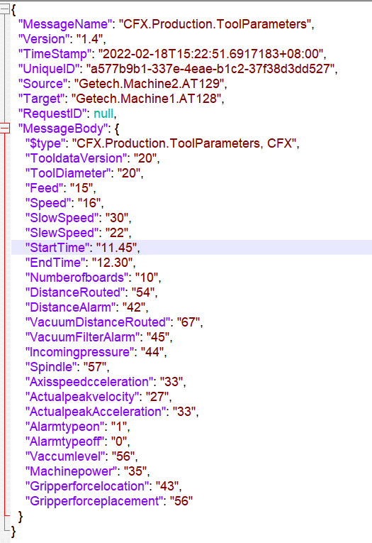

**ReadPanelBarcodeRequest Class**

ReadPanelBarcodeRequest Class with the new parameters added based on our Depaneling Equipment under CFX.Production and structures NameSpace.

**Pull Request**

None

**Updates to the Standard**

**A.5 IPC-2591, Version 1.5 Changes**

**Messages: CFX.Production.ReadPanelBarcodeRequest**

|  |  |  |
| --- | --- | --- |
| **ReadPanelBarcodeRequest** | **Type** | **Description** |
| nodePanelSerialNumber | string | Unique ID of Production Unit, Panel |
| nodePanelEntryTime | DateTime | PanelEntryTime |

**CFXMessageFormat:**

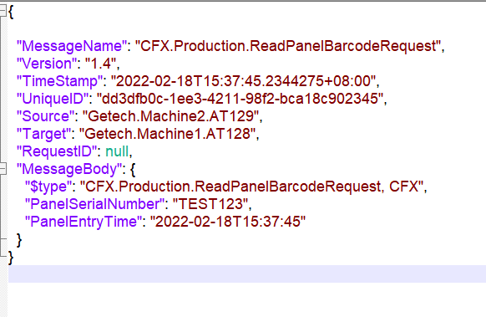

**ReadPanelBarcodeResponse Class**

ReadPanelBarcodeResponse Class with the new parameters added based on our Depaneling Equipment under CFX.Production and Structures NameSpace.

**Pull Request**

None

**Updates to the Standard**

**A.5 IPC-2591, Version 1.5 Changes**

**Messages: CFX.Production.ReadPanelBarcodeResponse**

|  |  |  |
| --- | --- | --- |
| **ReadPanelBarcodeResponse** | **Type** | **Description** |
| Result | Class | Result of the Request |
| ScanResult | Class | ScanResult of the Request |
| PannelMappingResults | List | A Optional List of PannelMappingResults |

**Messages: CFX.Structures.Depaneling**

|  |  |  |
| --- | --- | --- |
| **ScanResult Class** | **Type** | **Description** |
| PanelSerialNumber | String | Unique ID of Production Unit, Panel |
| TestResult | Class | Result of the test |
| FailureCode | Int | In the case of a failure, an integer-based, endpoint-specific error code indicating the nature of the failure |
| Message | String | In the case of a failure, a human readable message indicating the nature of the failure |

**Messages: CFX.Structures.Depaneling**

|  |  |  |
| --- | --- | --- |
| **PannelMappingResults Class** | **Type** | **Description** |
| PCBNumber | String | Unique ID of the Production Unit |
| PanelValidationResult | Enum | Enumeration indicating the Result of the Panel Validation Operation |
| X | String | X Coordinate of Production Unit |
| Y | String | Y Coordinate of Production Unit |

**Messages: CFX.Structures.Depaneling**

|  |  |  |
| --- | --- | --- |
| **PanelValidationResult Enum** | **Type** | **Description** |
| GOOD | 0 | The Validation has Succeeded |
| BAD | 1 | The Validation has failed(Not Succeeded) |

**CFXMessageFormat:**

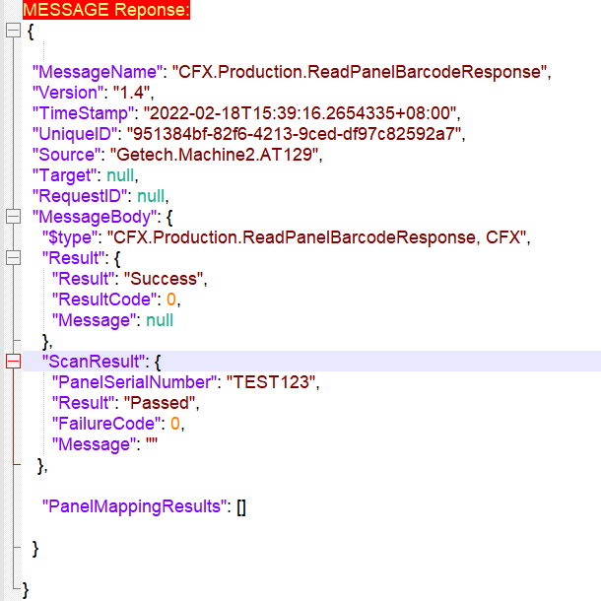

**CFXMessageFormat:**

